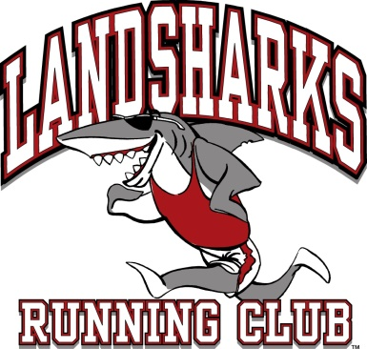
Landsharks Running Club
Fall Cross Country Running Series at
Mountainside Elementary!!
We offer a non-competitive youth program to introduce running to young athletes in a safe and fun environment. The focus is on self-improvement, being an encouraging teammate, and making new friends. The Fall XC Series is a five/six-week school program led by Rikki Carey and is open to students in kindergarten through 6th grade. A Red team t-shirt ($15) is required for all runners and is good for both the fall and spring seasons.
So, no need to buy one if you already have one, and it still fits.
1st practice date: Thursday, September 6, 2018
Practice times: 2:30-3:30 pm. Meet on the field behind the school.
Practice days: Mondays, Thursdays and Fridays. No Monday practices on meet weeks.
Parent meeting: Thursday, September 6th at 3:15 pm
Practices consist of running games and workouts with a strong focus on fun.
Races are held on Mondays at Janitell Middle School
on September 24th at 6:00pm, October 1st at 6:00pm and October 8th at 5:45pm
Runners can run the following distances:
Kindergarten & 1st grade 1/2 mile only, 2nd-5th grade 1 mile OR 1.5 miles.
At the races, runners receive a race tag with their number, ribbons, a series medal at the final race, and refreshments. Race results are posted on the Landsharks website.
I look forward to working with Your Athletes!
Please consider volunteering to help coach or work at our race site.
If you have any questions or would like to volunteer (no experience necessary) please let me know!
Coach: Rikki Carey Email/Phone: natandjojosmommy@gmail.com/719-209-6585
Runners must be registered prior to their first practice.
Please register online at www.Landsharksrunningclub.com
beginning August 6, 2018. Registration will close on September 6, 2018.
($59 registration fee until September 4th, then a $10/runner late fee applies)
FINANCIAL AID AVAILABLE for those who qualify.
Applications available from August 6th-August 26th

