Keyboarding Skills
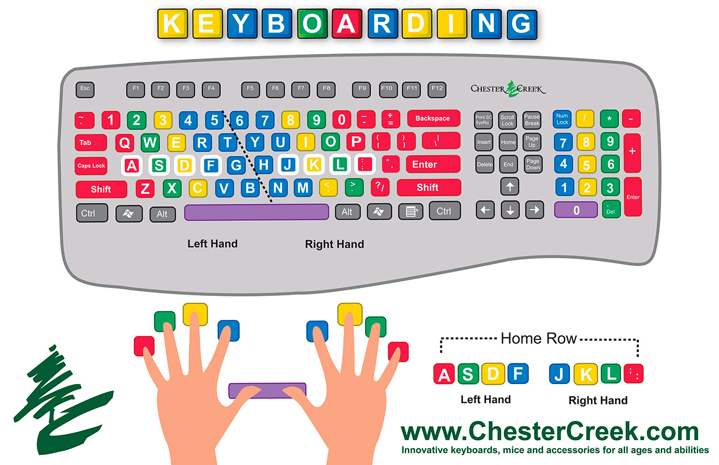
Welcome to Media Club! We are happy to have you here to learn Touch Typing!

Learning how to Touch Type begins with the home row.
There are three rows of letters on a keyboard. The middle row is the home row. The home keys are where your fingers rest when you are typing. The home row of the keyboard is the most important to the touch-typist. When at rest, the typist's fingers are positioned lightly on the A-S-D-F keys for the left hand and the J-K-L-; keys for the right hand.
The F and J keys often have small raised bumps on their tops, which is a tactile aid for the typist. The locations of all the other keys on the keyboard are learned in relation to these home keys so the touch-typist must be able to find the home keys by touch. Touch typing is a skill that is learned by practicing.

When learning how to Touch Type, follow these principles.

- Look at the screen.
- Hit the keys squarely in the center. Say the name of the key as you strike it.
- Don't let your mistakes discourage you.
- Take regular breaks.

Typing Ergonomics
Here are some of the key things to keep in mind
with respect to typing posture and hand position:

- sit up straight with your feet on the floor

- have the top of the monitor at eye level

- hands should be slightly lower than elbows

- keep the backs of your hands parallel to the keyboard

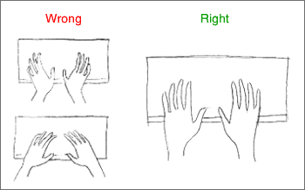
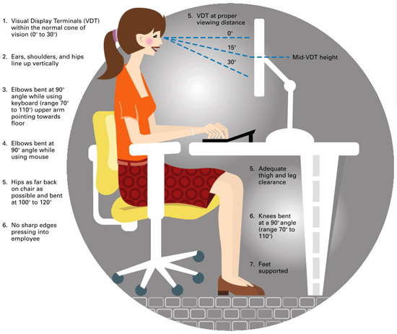
- keep your wrists straight

