thanksgiving Feast
Thursday, November 20th, 2014
Mountainside Elementary Cafeteria
Cost: Normal for students and $2.80 per adult/sibling
10:00-10:30* Rocchio, Frazer, Yamamoto, Hansen
10:30-11:00* Lemm, Farrior, Donohoo, Lee, Palmiotti
11:00-11:30* Fishman, McKinney, Sutter
11:30-12:00* Dooley, Hudson, Powell, Connor
12:00-12:30* Hughes, Griffin, Paulson, McMullen
12:30-1:00* Feldt, Solon, Shugart, Bagshaw, Johnson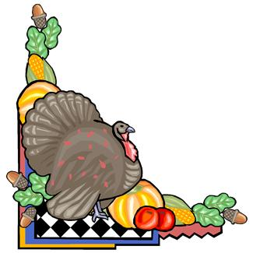 Please RSVP by 11/14/2014
*I will not have change for big bills so please bring correct change*

